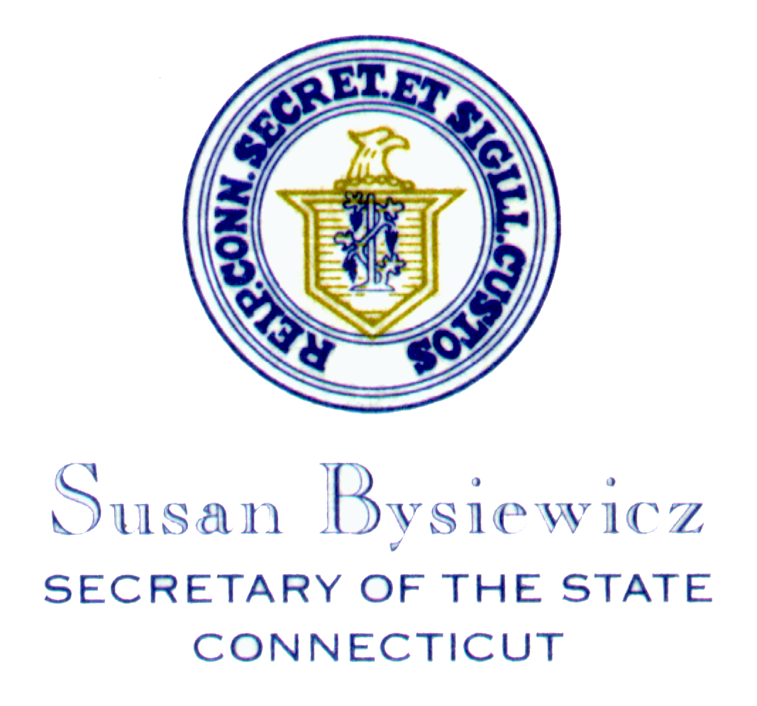

For Immediate Release: For more information:
February 1, 2008 Adam Joseph: (860) 509-6118
Cell: (860) 817-4165

- Press Release -

Voter Registration in Connecticut Hits Record Levels as Races Come Down to the Wire

Secretary Bysiewicz reports more than 34,000 residents have registered to vote

Hartford: Secretary of the State Susan Bysiewicz today announced that record voter registration in the past 90 days will translate into record voter turnout for the Connecticut’s Presidential Preference Primary on February 5th – Super Tuesday.

“Registrars of voters across the state have reported a surge in voter registration,” said Bysiewicz. “Moving Connecticut’s primary date from March to February gives candidates a real stake in Connecticut and the lively close race for the White House has energized voters. I am urging every eligible resident to go to their Town Hall by Monday February 4th at noon, register to vote, enroll in a party, and make their voice heard.”

From November 1, 2007 through January 31, 2008 more than 34,000 new voters registered to vote. Among newly registered voters more than 17,500 Democrats and Republicans 6,300 registered to vote. Additionally, more than 13,300 unaffiliated voters switched their registration to the Democratic Party while more than 3,600 unaffiliated voters enrolled in the Republican Party in order to vote in the February 5th primary. Of the more than 34,000 newly registered voters, nearly 8,300 are between the ages of 18 and 29. Since November 1st, among newly registered younger voters, Democratic registration has outpaced Republican registration: 4,846 to 1,347.

“As a result of joining Super Tuesday Senators Clinton, McCain and Obama, will be campaigning in Connecticut in the final days before the primary,” Bysiewicz said. “It is clear that moving the primary from March to February has paid off for our state.”

The Office of the Secretary of the State maintains an aggressive voter registration program. As part of her effort to increase voter registration in Connecticut, Secretary Bysiewicz this past year registered more than 1,000 high school students. Secretary Bysiewicz has conducted more than 200 voting machine demonstrations highlighting the new machines and registering voters. The Office of the Secretary of the State also registers new citizens to vote at naturalization ceremonies across Connecticut.

CURRENT ACTIVE VOTERS BY PARTY AS OF 02/01/08

PARTY COUNT
-------------------------------------------------- -----------
A Better Future 2
A Connecticut Party 56
A Sentinel Party 36
Concerned Citizens 294
Connecticut For Lieberman 15
Democratic 687,828
Enfield Taxpayers Party 2
Friends Of Saybrook 19
Green 1,844
Independence 877
Independence For Montville 11
Independent 1,723
Libertarian 823
Norwich for Change 1
Orange Taxpayers 8
Pro-Bethel 5
Reform 90
Republican 411,400
Swing 2
Unaffiliated 819,435
Waterford Independent 1
Winsted Independent 43
Working Families 11
===========
Total Active Voters 1,924,526

Voter registration forms can be downloaded from the Secretary of the State’s website by visiting: http://www.sots.ct.gov/ElectionsServices/electforms/ed671.pdf

Previous Presidential Primary Turnout

2004 Democratic 20.4%
2000 Republican 40.8%
2000 Democratic 28.8%
1996 Republican 28.4%
1988 Democratic 36.8%
1988 Republican 23.8%
1984 Democratic 33.0%
1980 Democratic 33.2%
1980 Republican 43.3%

